Hyperion Systems  
Innovation in Efficiency

Iman Ballou, Zakaria El Jbari (Team Lead), Michael Georgiou, Daniel Niles, Kishan Patel, Amanda Pistone, Cesar E. Quezada

ISM 3113 Systems Analysis & Design

Prof Agnieszka Onuchowska

1. **System Requirements Review** 
   1. Summary and background of the business process
      1. Our system is the Advising Tool Schedule Planner System. This add-on collects and parses student information from Degreeworks and populates a list of classes a student should take based on their requirements and electives needed. This will help students see their plan and register accordingly to stay on track for graduation. Additional features such as a registration button and email advisor button will also be added to enhance the registration experience for students. The add-on would not only alleviate a lot of the confusion inherent in the current Schedule Planner, but also improve the quality of the work USF advisors are able to provide to students and help improve the university’s overall graduation rate.
   2. Identification of the objectives and goals of the business process
      1. List and description of requirements the system must meet
         1. The add-on shall collect and analyze student information from Degreeworks
         2. The add-on shall provide a form that will send an email to the student’s advisor, allowing them to request course permits, ask questions about their schedule, and make sure that they are on track
         3. The add-on shall display hierarchical list with 4 levels: Course Category, Course, Course Section, and Section information respectively
         4. The add-on will transfer CRN numbers from the selected courses in the registration cart directly to the Oasis registration page
      2. Identification of the features and functions for each requirement
         1. Requirement 1
            * Feature 1: Collects information from Degreeworks

Function: Add-on is linked to student’s Degreeworks and reads its data

* + - * + Feature 2: Analyzes and categorizes information

Function: Read data is analyzed, filtered, and sorted by student and university imposed criteria

* + - 1. Requirement 2
         * Feature 1: “Contact Advisor” feature

Function: A button that will generate a blank email form to send to an advisor via the USF email system

* + - * + Feature 2: Email form where students can reach out to advisors for any questions or concerns

Function: Email form will provide space for students to ask questions. The email will go through the USF email system to their advisor and a confirmation email will be sent to the student

* + - 1. Requirement 3
         * Feature 1: Dropdown arrow feature for first three levels

Function: Once arrow button is clicked, the next sublevel will be displayed with all the relevant information

* + - * + Feature 2: Prevent time conflicts with other classes and student selected breaks

Function: System will contain a filtering algorithm that automatically eliminates classes that conflict with already selected classes and/or breaks

* + - * + Feature 3: Drag and drop course section into current schedule feature

Function: each course section will be a draggable item that can be dropped into the current schedule

* + - 1. Requirement 4
         * Feature 1: Add-on “register” feature in the shopping cart redirects users to add/drop page from Oasis in a new tab

Function: Button that creates a custom link based on classes the student has picked to the add/drop page in a new tab

* + 1. Assessment of which requirements the current system, manual or automated, fails to meet (if a BPR effort).
       1. Our system is not a BPR effort because we are not re-engineering a system, merely adding on to it
  1. Alternative solutions for the system
     1. Possible improvements: Patches, Upgrades, Completely New System.
        1. Update/ patch the current schedule planner to include these requirements, creating a more streamlined scheduling experience for the student
     2. Elements of the system that may be reused:
        1. Entire system will be reused
     3. Recommended course of action
        1. We recommend the implementation of the Advising tool add-on to the current system. The tool is both logically and economically feasible for USF. In addition, it will generate significant tangible business value in the form of streamlining and automating the advising process and improving the university’s graduation rate. Finally, there will be several intangible benefits such as student and advisor satisfaction.
  2. Identification of Proposed System
     1. Requirements Gathering for the system: Stakeholders, Features, Functions, Priorities
        1. Requirement 1 is collecting and analyzing data from Degreeworks. Primary stakeholders of this requirement are students and the secondary stakeholders are advisors, administration, and USF IT. The first feature of this requirement is that it collects information from Degreeworks. Its function is that the system will be linked to the student’s Degreeworks and reads its data. The second feature of this requirement is that it analyzes and categorizes read student information. Its function is that the read data is analyzed, filtered, and sorted by student and university imposed criteria. The third and last feature of this requirement is that the system will display classes in lists. Its function is that the system will populate classes sorted by priority for student the students grade year. This requirement’s priority is high.
        2. Requirement 2 is adding an email form to the system. Primary stakeholders of this requirement are students and secondary stakeholders are advisors, administration, and USF IT. The first feature will display a “Contact Advisor” button. Its function is it will generate a blank email form to send to an advisor via the USF email system. The second feature is the email form where students can reach out to advisors for any questions or concerns. Its function is that the email form will provide space for students to ask questions. The email will go through the USF email system to their advisor and a confirmation email will be sent to the student. This requirement’s priority is low.
        3. Requirement 3 is displaying a list with a logical and hierarchical order. Primary stakeholders of this requirement are students and secondary stakeholders are the Administration/IT department. The list will contain 4 total levels where each sub-level can be accessed by pressing the arrow down button from the previous level. The levels are Course Category, Course, Course section, and Section Information, respectively. The aforementioned down arrow button is one of the features of this requirement. The function of this button is to display the proper information in each sublevel when clicked by the user. The list will have a feature that prevents from displaying course sections that present a time conflict. Feature is achieved through a filter function supported by an algorithm. The final feature is that it enables the user to drag and drop items from the list into their current schedule.
        4. Requirement 4 adds a register button in the Schedule Planner’s shopping cart that redirects to the OASIS add/drop page. Primary stakeholders of this requirement are students and secondary stakeholders are the Administration/IT department. The feature is enabling students to register for classes in the shopping cart by opening a new tab with the add/drop page after clicking on the register button. The function is that the button generates a custom link using the classes the student has selected that opens the add/drop page with all CRN’s prefilled. This requirement’s priority is high.
     2. Supporting configuration document (CSCI) of system with traceability of each requirement to its quality criteria and user test cases

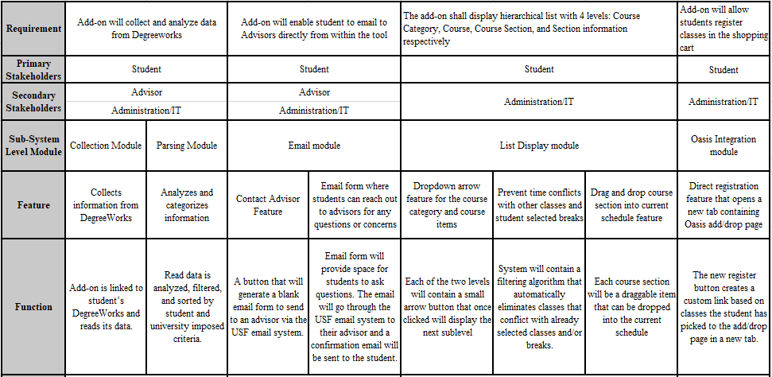

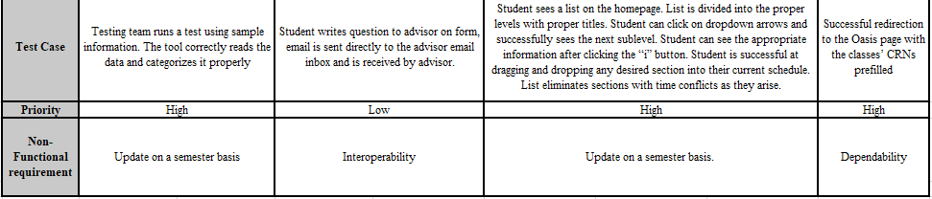

1. **Preliminary Design Review**
   1. Scope of the project Statement of Work
      1. Scope of Project

The Advising Tool Schedule Planner System will be designed and developed to seamlessly integrate with the current Schedule Planner system. End users of this system will be University of South Florida students. The improved product will contain a comprehensive registration experience customized to each individual user. This enhanced system will also be able to analyze data from the Degreeworks system and reorganize the information in a user-friendly manner directly accessible from within the Schedule Planner. The system should automatically be able to recognize each student’s outstanding required classes and needed electives as well as provide the appropriate class options in order to fulfill these requirements. The system will use the student’s year, major, and the number of credits taken to suggest classes in the appropriate sequential order. In order to further optimize the experience, the system will enable the students to initiate an email with any questions or concerns that they might have that will directly be sent to a queue for all advisors or a specific advisor of their choice. It will also enable them to click a button and automatically register for the courses they selected.

The purpose of the project is to add additional functionality to the existing schedule planning system. Using this tool, students will be able to feel more confident when registering for classes and advisors will be able to contribute in a much more meaningful way. All of the features of this tool will provide students with more ease of access and peace of mind, by displaying courses in an easily understandable way. We feel that this add-on is exactly what the current system needs in order to better serve the USF student community in a useful way.

* + 1. Product Acceptance Criteria
       1. System needs to be compatible with several browsers including Google Chrome, Mozilla Firefox, Safari, Internet Explorer
       2. System should successfully integrate with Degreeworks, Oasis, USF email system, and current Schedule Planner
       3. System should generate hierarchical list that accurately reflects the categories and the specific classes needed by the student
       4. System should automatically update on a semesterly basis
    2. Project Deliverables
       1. Tutorial Video showing students on how to properly use the improved system
       2. Preliminary User Interface design will be provided by our group and sent to USF IT administration for confirmation
       3. List of pre-selected advisors and students that will receive the Beta version for testing
       4. Our team will also define monitors and controls that will be later used by USF IT to provide support
       5. Our group will draft a plan that details all aspects of the system’s maintenance and support. We will provide comprehensive training to USF IT on how to maintain and provide help desk support to users
       6. Upon completion of training, our team will provide final debugged source code including add-on algorithm for our system
       7. Final debugged product will be ready for release by May 20th following Beta testing
    3. Project Exclusions
       1. Team will not be responsible for maintenance and support of the system following the provided training
       2. Our add-on will not affect the current system’s features
       3. Team will not be responsible for monitoring the system and predefined controls
    4. Project Constraints
       1. Project budget will be defined by USF IT and will dictate the amount of capital available for development
       2. Human capital constraint regarding the quality and quantity of developers in accordance with granted budget
       3. Timeline constraint to meet the release date and other important deadlines
    5. Scope Change Management
       1. A governance board will be formed that will include: Project Lead, USF IT Administrator, and key members of the development team
       2. Any scope change will require a Scope Change Request Form submitted to the board. This form will include all of the following essential components:
          - Impact on timeline
          - Reason for change
          - Comprehensive Cost-Benefit Analysis
          - Implications and consequences if change is not approved
          - All parties/stakeholders affected by the requested change
       3. The governance board will put the request to a vote upon reviewing the request form and assessing the risks and repercussions associated with the change. The board may approve, reject, or defer pending new information.
  1. Work Breakdown Structure
     1. Planning phase
        1. Identifying Team Leader
        2. Form Project Team
        3. Identify Stakeholders
        4. Define System Requirements
        5. Prioritize System Requirements
        6. Define the scope of the project
     2. Design phase
        1. Develop the add-on that integrates Degreeworks with Schedule Planner
           + Code a function that pulls information from the existing Degreeworks database
           + Create and structure a database that categorizes course catalogs

Cross Reference this data with the Degreeworks data

* + - * + Code and design an add-on that lists the classes information

Design populating box for course information

Coding to link the box to the information from our catalog database

* + - 1. Develop the e-mail add-on
         * Create the “Advisor Contact” button

Design the “Advisor Contact”’ button

Change page layout to accommodate button

* + - * + Create the email form

Design the form to conform to the current Oasis page style

Display a list of recommended advisors to select from

* + - 1. Develop the down arrow button for each level
         * Create an down arrow button for each class

Design the down arrow button

Change layout of page to accommodate button

Link the down arrow button to the course information pop-up box

* + - 1. Develop the register button that transfers classes to Oasis
         * Create a “Register” button

Design the “Register’ button

Change page layout to accommodate button

Code the button to link to add/drop page on Oasis

* + - * + Code a click event that transfers the CRN(s) directly to Oasis

Link this click event to the “Register” button

* + 1. Testing phase
       1. Deliver Preliminary version to USF IT
       2. Select advisors and students testing Beta version
          - Analyze data from Beta testing
       3. Make any pertinent changes based on data from Beta Testing
       4. Regression testing
       5. Training of USF IT support staff
          - Draft a plan for future IT support
    2. Implementation phase
       1. Provide final debugged product
          - Get final acceptance from USF IT
       2. Create a tutorial video of the new add-on
       3. Release final product
  1. Project Schedule
     1. Gant Chart:

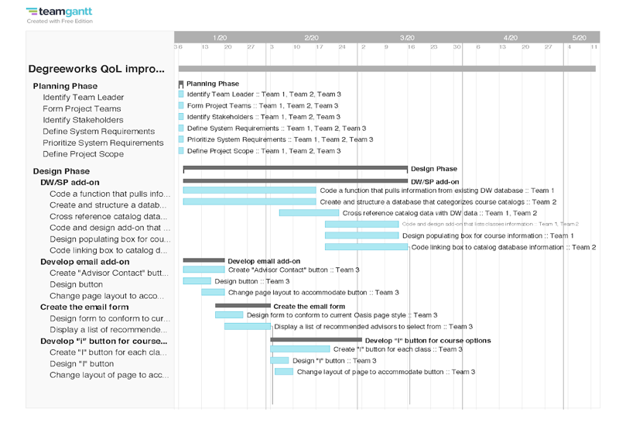

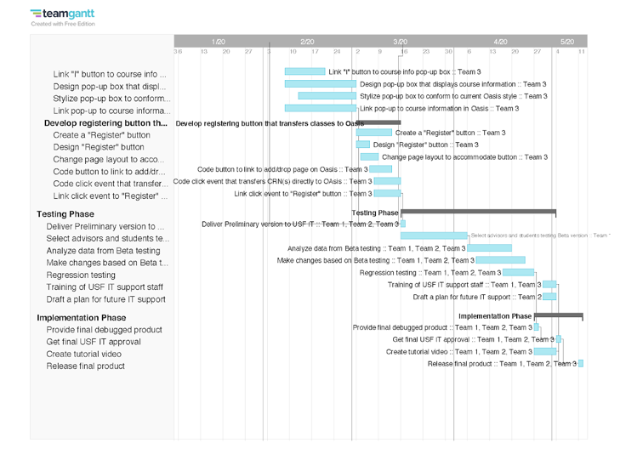

* 1. Identification of development team
     1. Project Lead – Zakaria (Zak) El Jbari

Our project leader Zakaria will be responsible for making sure all parts of the project are running smoothly. He will oversee the engineers and trainers who will report to him to ensure requirements are being met in a timely fashion. He will be working closely with the USF IT Department to obtain access to the software and data necessary to start designing the project. Additionally, he will supervise the design, testing, and implementation phase. He is the most experienced in the IT field in our group and is an excellent team leader.

* + 1. USF IT Database Engineer - Cesar Quezada

Our Database Engineer Cesar is exceptional at what he does and has many years of experience in the field and is committed to creating a more streamlined scheduling experience for the student. He will be working closely with engineers of USF Schedule Planner System and Degreeworks to maintain database integrity and linkage to ensure proper system integration. His main duty will be to make sure course information and catalogs can be cross referenced.

* + 1. USF IT Software Engineers - Kishan Patel and Michael Georgiou

Kishan and Michael will work together to restructure the schedule planner and create and implement a patching timeline. They are both highly experienced in their field and work closely with the USF IT Department. Kishan and Michael will make sure the requirements are realized  by programming and working closely with Cesar, who offers his database expertise. They both will be adding many features to the existing Schedule Planner, such as the email add-on, email form, and “i” button layout. They will also be responsible for designing the hierarchical feature that will incorporate course information sorted by filters and the “register” button that will generate a link in a new tab to the Add/Drop Page. They are trusted developers and have a great track record.

* + 1. USF IT Data Analyst - Iman Ballou

Iman will make sure all the data required for system updates are in order. She will gather data, organize and work closely with other engineers to make sure requirements are being met. She will also take part in the Beta testing to make sure it is running smoothly. Over the years she has been a big part of the USF IT Department and is very motivated to accomplish this project.

* + 1. USF IT Quality Assurance Engineer - Amanda Pistone

Amanda will be our QA tester, she is a very experienced individual. She is energetic and detail oriented which made her a perfect fit for this project. Amanda will have a lot of influence in the Beta testing and final IT acceptance. She will work closely with the other engineers to debug the system and make sure all of the defects are addressed for the final testing. She will be analyzing the student and advisor feedback from early testing and implementing the changes needed for each subsequent testing phase

* + 1. USF Implementation and Training Managers - Daniel Niles

Daniel will be in charge of making sure the new system gets implemented correctly and in a timely manner according to schedule. He will oversee the Beta testing between students and advisors and report to Zakaria. He is very skilled in his department and brings a lot of value to the team. He will also be in charge of training IT Staff Support for the system. Lastly, he will develop a tutorial video for new add-on.

* 1. Identification of test team

Our Test Team comprises of Amanda, Daniel, Iman, Kishan and Michael. The Test Team for the Advising Tool Schedule Planner System will be responsible for ensuring the application runs as intended. The Test Team will provide a preliminary version of the program to USF’s IT Department for quality assurance. Upon the completion of internal testing, our Test Team will release a Beta Test. All changes to the application will be implemented, and the Test Team will then begin regression testing to completely debug the application. The application will undergo its final revisions and debugging process and be released to the USF community on May 11th.

* 1. Risk Analysis

With the redesigning of the pre-existing Schedule Planner application comes high risk. When developing a project of this stature it is crucial to analyze and check the risks, so that the project can be successful. The potential risks for this project include the following:

* + 1. Exceeding the time limit resulting in the application not being ready by May 20th
    2. Exceeding the budget potentially due to exceeding the time or hidden costs
    3. The number of bugs within the application delaying the Beta testing and release
    4. Releasing the application with an accidental bug which will result in delay of USF students class registration
    5. Students and Staff being unhappy with the new design of the Advising Tool Schedule Planner
    6. Focus group requesting unintended additional features delaying the schedule for release
    7. Databases are not linked and/or linked incorrectly will result in incorrect course information
    8. Email Advisor Form is visible but does not function as intended, will cause confusion between students and advisors
    9. “i” Icon does not display as intended, will cause delays in registration and confusion
    10. Add/On redirect to Oasis link could be broken, or could fill in wrong class CRN’s

Although the risk of this project is high, the payoff is high for the University of South Florida. If the above risks are analyzed thoroughly, USF will receive increased student and staff satisfaction due to the easement of the registration process. In order to avoid the above risks, each one should be taken seriously and analyzed thoroughly. By being aware of the above risks the team will be able to minimize the risk of the project.

1. **Critical Design Review**
   1. User screens and forms with brief descriptions

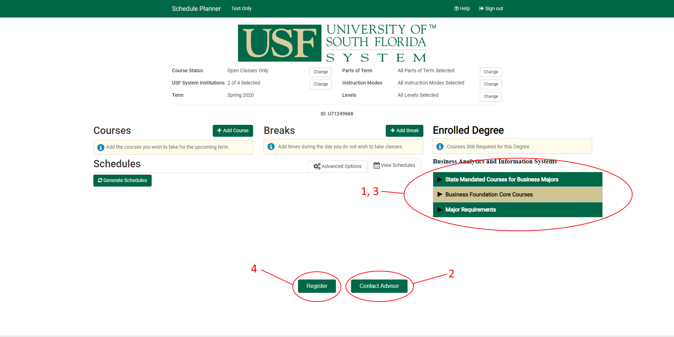

In this wireframe image, there are three circled additions to the current Oasis Registration page. To see the prototype without the circles and annotations, go to section 3 of the CDR. These circled components are numbered to correspond with the requirements defined under the SRR and PDR. The basic functions of this addition are two buttons and a collapsible list. More detailed descriptions of their functions and features are given under section 2 of the CDR.

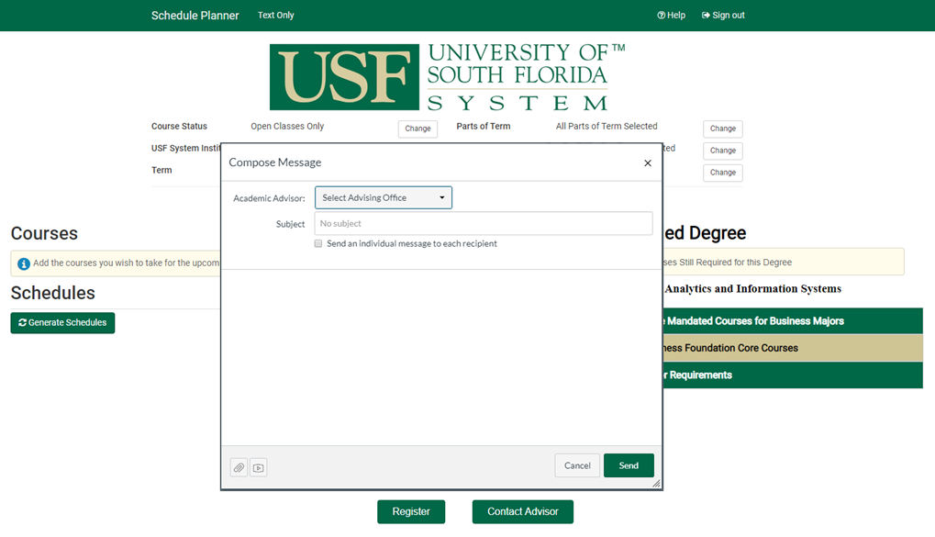In this wireframe image, the basic function of the Contact Advisor Button is shown. Once the button is pressed, an email form identical to the one shown above pops up.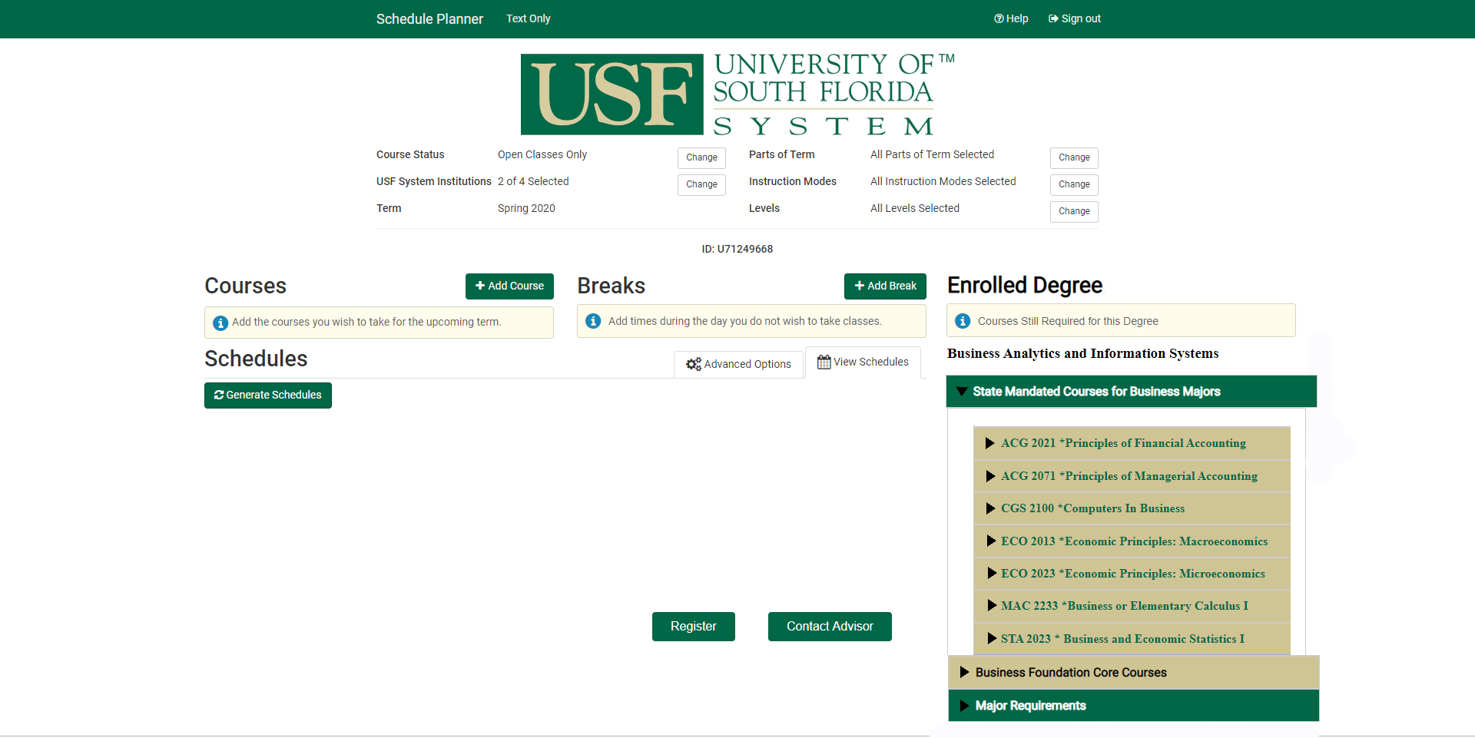

The third image in the wireframes basic function demonstrates the collapsible list. When a section such as the State Mandated Courses section is selected, it expands into a list of courses.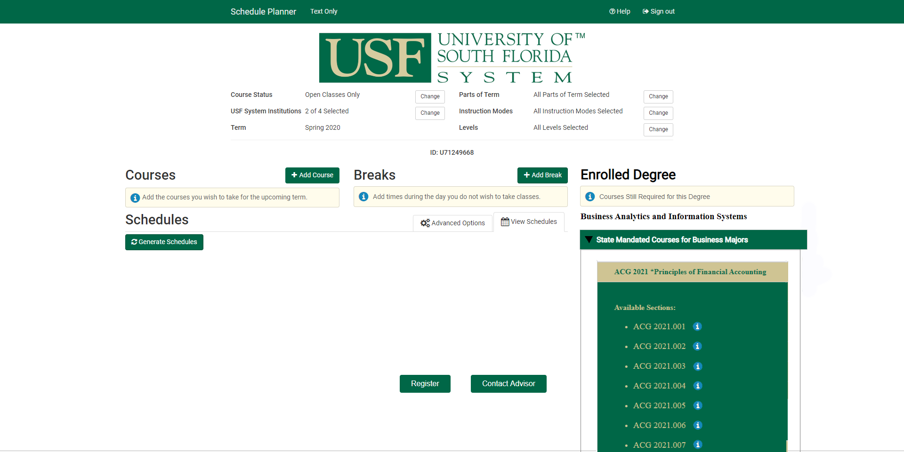

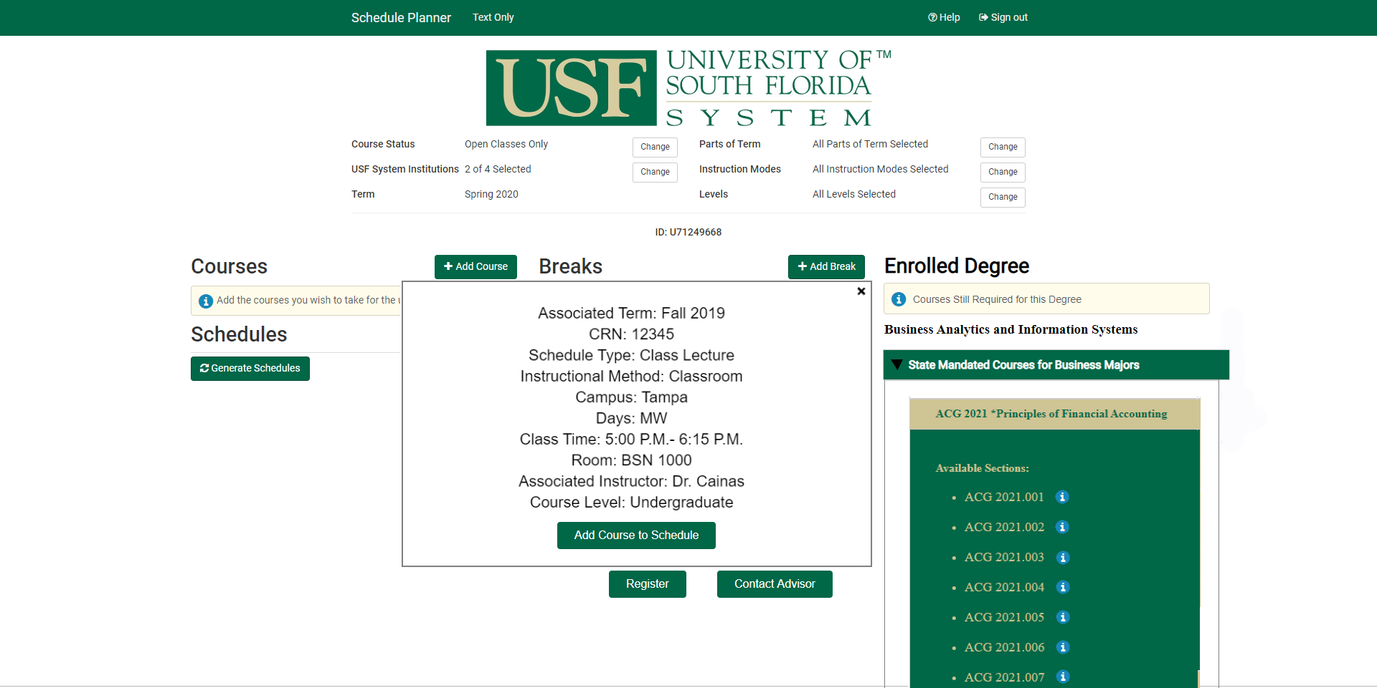

Image demonstrates another basic function to the collapsible list. When a course is selected, it drops.

Wireframe image 5 demonstrates the basic function of the “i” button. When selected it creates a popup with all relevant course information.

* 1. Detailed descriptions of system components
     1. The first image in the wireframe is an annotated prototype design for the revised Oasis Registration page. For a version without the annotated numbers, go to section 3 of the Critical Design Review. The numbers on Image 1 represent the requirements listed under the SRR and PDR. Requirement 1 is the collection and analyzation of Degreeworks information. Requirement 2 is the addition of the “Contact Advisor” button. Requirement 3 is the addition of the I-button for course information, and Requirement 4 is the addition of a “Register” button.
     2. The second image displays the functions of requirement 2. Feature 1 of this requirement is the addition of the “Contact Advisor” button itself. Feature 2 is the email form that displays when the button is clicked. This form allows a user to select an advising office to email from a dropdown list.
     3. The third image is a part of requirement 1. The information pulled from Degreeworks includes courses taken as well as courses needed to graduate. All of this information processing is done on a server as listed in the PDR. The user does not see this feature of the requirement, only the end result. The list shown will only display courses that have not been taken.
     4. The fourth also pertains to requirement 1. The drop down list displays all of the available sections in the selected course. This list is also pulled from the already existing USF Degreeworks infrastructure. Next to every section is an “i” button that can be selected for more information of that particular section. The “i” button is a feature of requirement 3.
     5. The fifth image is another feature of requirement 3. When the “i” button is selected, a popup is displayed. This popup displays all relevant information about the selected section. This information is all pulled from the USF system. It includes information such as the instructor, meeting times, CRN, and meeting room. The popup also includes an “Add to Schedule” button, which when clicked adds that specific section to the student's schedule. Once a student is satisfied with their schedule, they can click the “Register” button. This automatically registers the student for their selection, bypassing the old system of registering on a separate web page in Oasis.
  2. Prototype Design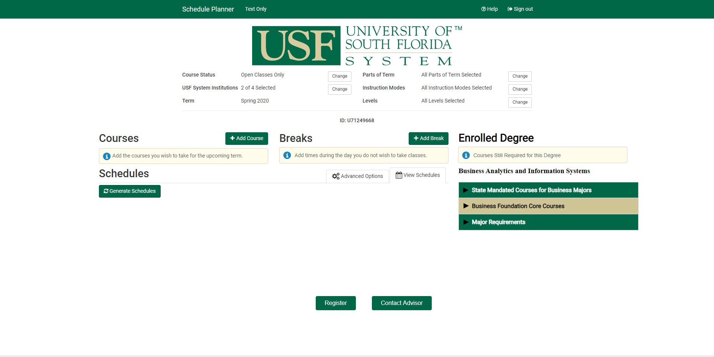
  3. 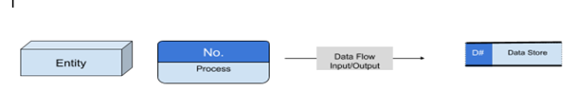System Process and Model

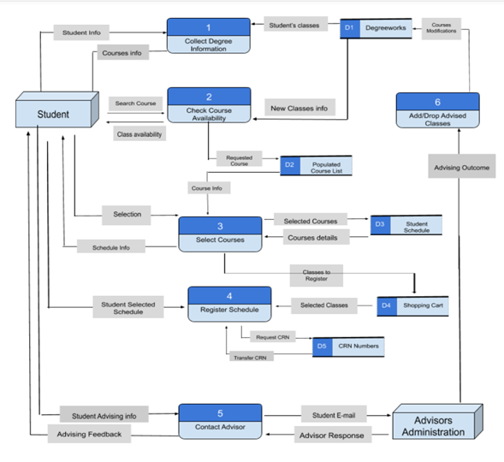

* 1. Cost Management

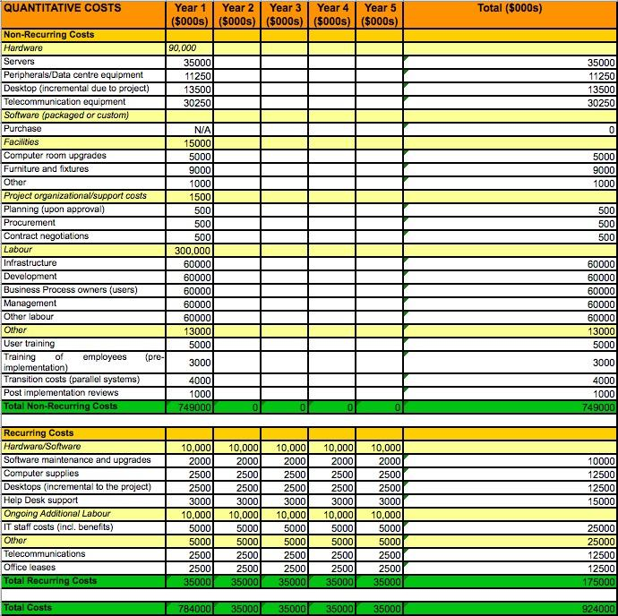

* 1. SWOT & PEST Analysis
     1. SWOT

Strengths

* + - * + *System Experience*: Our team, consisting of USF students, has first-hand experience with the current system and its limitations, and great understanding of the potential areas of improvement.
        + *Human Resources*: We have the benefit of knowing and being able to consult with USF faculty as well as other students who are the end-users and may be helpful in realizing our vision.
        + *Lower Cost*: Our team can also make a lower bid than our competitors as we can be compensated in kind, for example with credit towards degrees being pursued.
        + *Ongoing Support*: Those on the team who will continue to be on campus may be able to offer support for an initial trial period, which would be extremely valuable to the University and teams that will be trained

Weaknesses

* + - * + *Brand*: Our brand is not highly recognizable and lack of reputation may cause the University to look elsewhere
        + *Ethical Concerns*: The University may have concerns with students working on internal systems as a conflict of interest may present itself. Of particular concern is the potential for team members to alter transcripts or financial data

This can be addressed with accountability procedures

Opportunities

* + - * + *Ability to Manipulate Demand:* The University, as far as we can tell, is unaware of the demand for such an upgrade, and therefore is unlikely to search for a solution unprompted

Demand for the upgrade comes from the student body

Students are likely to express a desire for the upgrade if asked

We can create the demand for our system at a convenient time as we are part of the student body and can raise awareness at any time

* + - * + *Promise of Improved Revenue and Enhanced Reputation*: The University has previously expressed interest in getting students to take more classes per semester, likely because this improves the probability of graduation, and leads to students taking more classes overall

Our upgrade greatly improves the ease of adding classes, and therefore will almost certainly increase the number of classes added. This is potentially valuable to the University

* + - * + *Reduced Costs:* The upgrade, in assisting students to add the classes needed for a given degree, may reduce students’ need to see an advisor for the same reason

This may reduce the need for advising staff, which could save the University money

* + - * + *Other Projects:* After successful completion of this project, the University is more likely to partner with us again

We may be able to identify other projects to work on in the future

Threats

* + - * + *External Vendors:* Other software vendors and solutions providers are our primary threat once the University realizes the demand for the upgrade

The vendor that supplied the current system will undoubtedly be consulted

The University will certainly seek quotes from other professional organizations for the same upgrade

It is important that we can offer either a lower cost or a superior service to our competitors

* + - * + *Ability to Execute*: We must consider our own ability to complete the upgrade with the resources allocated

If we are, in fact, unable to adhere to the terms of the contract, we may face legal repercussions

* + - * + *Change of System:* Should the University at any time decide to overhaul the current system, our upgrade will be rendered redundant

Software as a Service is a trend that greatly threatens the current system and, by extension, our upgrade. If the University moves to SaaS, the only entity that can make changes to that system is the vendor

* + 1. PEST

Political

* + - * + The current system may be protected from modification by copyright or licensing agreement
        + Pressure to maintain preeminence may motivate upgrade
        + Upgrade must meet FERPA requirements

Economic

* + - * + Potential economic recession may cause the University to spend more conservatively, lessening the chance of a decision to upgrade
        + Economic growth may pressure the University to streamline registration process to accommodate increased volume
        + High costs associated with the upgrade
        + Breakeven analysis may not be in our favor
        + Competitors may have cost advantage due to scale

Social

* + - * + Pressure from students may motivate the University to upgrade
        + Could face pushback if reduced need for advising staff causes job cuts
        + Young people increasingly value convenience
        + Bugs may reduce use of new upgrade

Technology

* + - * + A change in the technology behind the current system may obviate the need for an upgrade
        + The current system may be difficult to upgrade
        + University may want upgrade faster than possible
        + University may require longer-term support than we are able to provide
        + Social media may provide an avenue to increase demand in upgrade
  1. Make or Buy Analysis

There are several considerations we have to make before making a decision on whether to make or buy this product. We decided that our product will be internally made and not purchased for the following reasons. First, we assessed our core competencies, and whether making this product internally is logical. The clear answer is yes because our team is extremely familiar with the current system and its flaws, and we specialize in software development and systems analysis. It is a rare opportunity and huge advantage that the entire team is an end-user of the system.

Second, the requirements of our system are very specific and customized to the USF system, and it will be extremely hard if not impossible to find an as-is product on the market that satisfies all of these requirements. Since the vendor would probably have to make modifications to any solution package they have already developed, they will likely charge a much higher price for the product. Another reason to justify our decision was that it would be much more cost effective. Finally, we do have the human and financial resources to develop this tool and this is a critical project that should remain internal.

* 1. Identification of Training Team

Given that our systems end users are a wide variety of people such as professors, young students, and older students our test team is designed to be accessible to all audiences. First our training team will be hand selected to represent different areas of our campus’ population for example, one member will have knowledge of the teaching field, another member will represent the older aged students, and another member will represent the younger aged students to ensure an equal understanding of the updated system campus wide. Our training team will additionally receive an in depth training on how to use the updated Schedule Planner System as well as be tested on their knowledge of the system upon completion of their training. Once we are confident in our training teams understanding of the updated Schedule Planner System they will each complete a video tutorial that will be available to all USF system users to aid with the implementation process of the updated Schedule Planner System. Lastly, the team will have a Training Lead who will be responsible for overseeing the successful completion and release of the training videos.

* 1. Identification of Transition Team

To ensure a successful release of the updated Schedule Planner system our transition team will consist of professionals who have experience with releasing school related systems. The transition team will have ample knowledge of the system and will ensure a smooth release for the upcoming semester. The transition team will be responsible for testing the Schedule Planner System prior to its release and making certain that it is completely debugged. The transition team will release a test version to a small portion of the USF population to aid a smooth transition for the full release. In the event that a bug is missed and the system has been released, the transition team will have an alternative plan to implement as a backup. Lastly, the team will have a Transition Lead who is responsible for overseeing the smooth release of the system as well as implement the alternative plan in the case of a bug.

* 1. Identification of Evaluation team

Our evaluation team will consist of one of the top school system evaluators who guarantees quality assurance, and working with him will be developers and engineers with applicable knowledge to school systems. This team will be responsible for documenting the progress of the Schedule Planner System throughout its creation, testing phase, and transition phase. Through the evaluation teams documentation process, they will be able to ensure that each requirement for the system is met. Prior to the release of the updated system the team will evaluate the application and provide feedback to the test team and transition team. Once the system is released, the evaluation team will evaluate it again and offer useful updates to the system.

1. **System Specification Review**
   1. Physical Characteristics of the System
      1. Physical space

The system will be hosted on the University of South Florida’s infrastructure. Natively hosting the addon is possible because of how little space it occupies, and provides benefits such as less potential overhead and an environment more conducive to the integration of the add-on within the overlying USF course registration system.

Currently, USF maintains its own server clusters running Windows Server 2016 for internal systems. The physical requirements of the system will not change with the deployment of this upgrade. The amount of processing overhead added will be negligible, ensuring compatibility with the current hardware. All infrastructure will remain the same. Further, the upgrade will require minimal ongoing maintenance, and current operational and support procedures will prove sufficient.

* + 1. Operating System

To ensure an easy transition, we will be running Windows Server 2016 as our operating system, the same Operating System USF runs for the majority of their internal infrastructure.

* + 1. Software
* MYSQL (database connections/links)
* Microsoft Visual Studio- (C++, C# , Ruby)
* .Net framework 4.7.2- web applications (Uses C#)
* Rollbar (Debugger)
* Pencil Project (Prototyping)
* Dreamweaver (HTML5 Development)
* vSphere (Patching)
  + 1. Operating/Maintenance and Training Personnel
       1. Maintenance will be conducted by USF IT
       2. Training personnel will not be required after the creation of the video tutorial
  1. Updates on Consideration for Alternatives and Options for Acquiring the New System
     1. Make versus Buy Decision

We will keep our make decision for our product. To reiterate our decision making process, we first established that our core competencies are directly aligned with the project knowledge requirements. Our team does not only possess the technical knowledge to build this system efficiently, but also have first-hand experience operating the old system as end users. Second, due to the specificity of the requirements and customized nature of the product, we established that the as-is products available in the market would need serious modifications in order to fit our needs driving the cost up even more. Finally, we do have the financial and human resources in order to effectively carry out this project, which further reaffirmed our make decision.

* + 1. Re-Use of Old System Components

Our team will reuse a substantial amount of the existing system that USF currently uses. We see no need to build an entirely new system since a lot of the current features and functions work well. Moreover, this would simplify the transition as the end-users will already be familiar with the system and would only need to learn how to use the additional tool. This also helps as they will be aware of the general layout of the program. The first minor change is the addition of the “Contact Advisor” button that will enable students to send an email directly to an advisor from within the same page. The more major change will be a list of suggested courses that students need to complete in accordance with their specific degree requirements.

* + 1. Sourcing Decision

Our sourcing decision was to develop the product In-House. We first ascertained that the product we are looking for would not be available off the shelf. The remaining decision was to choose between a vendor developer or produce in-house. Again, due to our extensive expertise in the field and our intimate knowledge of the system’s strengths and flaws, the more logical decision was to develop the product in-house. We also considered the cost of each option and determined that a vendor would have to spend ample time understanding the current system and Degreeworks first. Second, they would need to develop a system from scratch that met the requirements of our add-on and integrated with the current system. Finally, they would need to be heavily involved with the installation and transition as well as the support for after the product launches. All of these steps would require significant time and money, which would cost us much more than it would cost for us to develop our product in-house.

* 1. Development Environment Specifications
     1. Procurement
        1. The Schedule Planner and Oasis is already being hosted on the University of South Florida’s infrastructure
        2. The Add-on will be hosted on the USF organization, after it is tested and verified
        3. Physical space required will be little; a minimal room is required to store any physical hardware, application servers, and databases
        4. Physically, these requirements are already in place and will not change with the deployment of this upgrade
     2. Equipment
        1. Hardware
* Web Server (Existing) - Hosted by USF IT
  + The Web Server will display Oasis to the user, and work in conjunction with the Application and Database server to display dynamic content specific to the user.
* Mail Server (Existing) - Hosted through the Gmail client
  + The project’s function of sending an advisor an email will occur through this chosen server
* Application Server (Existing) - Hosted by USF IT
  + This server is where the Webapps added on by this project will be hosted
* Database Server (Existing) - Hosted by USF IT
  + The data displayed to the user is pulled from the existing database server using MYSQL
    - 1. Software
* MYSQL - V 8.0
  + The MYSQL software will  work in conjunction with the database and web server to find, organize and collate user data and course catalogues
* Microsoft Visual Studio 2019
  + Microsoft Visual Studio is a development tool that utilizes the .Net framework, and it will be used to create this project’s Webapps.
* .Net framework- V 4.7.2
  + The Webapps will be coded with the .Net framework, more specifically the C# language.
* Rollbar
  + Rollbar will be used for real-time debugging as the project is coded, as it is compatible with .Net
* Pencil Project - V 3.1.0
  + Pencil Project will be used to create wireframes/mockups of the final version of the GUI
* Dreamweaver 2019
  + Dreamweaver will allow the integration of the created Webapps with the existing system, using HTML5
* vSphere - V 6.7
  + vSphere will ensure that the created applications are efficiently processed on their chosen servers in an effort to reduce the possibility of downtime
    - 1. Operating System
* Windows Server 2016
  + As stated previously, this version of Windows Server was chosen to stay on par with current USF IT standards. Furthermore all software chosen previously is compatible with Windows Server 2016
    - 1. Memory
* RAM - 16 GB per server
* Hard Drive/Storage - 2 TB per Server
  + - 1. Support
* All Webapps and information passing through the system will be properly secured with the assistance of USF IT
* The project developers will work with USF IT to ensure the proper integration and deployment of the Webapps. This includes the deployment of the beta test and the final version
* The creation of a server snapshot will be necessary at the beginning of development. This will be used for development testing, so as not to interrupt the production server
* Once the final application is developed, backups will be made and given to USF IT. Further support will be done by USF
  + 1. Management
       1. Development Team

The development team will be responsible for developing the Advising Tool Schedule Planner System and ensuring it works seamlessly. When creating the Advising Tool Schedule Planner System the development team will stay on the time schedule, meet the systems requirements, and develop a bug free system. The team lead for the development team will be Amanda Pistone. She will be responsible for overseeing the development team and ensuring that the systems development meets all requirements and stays on track according to the time schedule

* + - 1. Governance Team

The governance team will be comprised of the Lead Developer, CEO, and Board of Directors. The governance team will be responsible for overseeing all scope changes and granting either a sign of approval or denial on a formal request document. Upon approval or denial, the governance team will additionally be responsible for revising the budget and timeline.

* + - 1. Test Team Update

Our test team still comprises of Daniel, Iman, Kishan, and Michael however, Amanda who was previously on the test team, has been transferred to Development Lead. The test team is responsible for launching a complete test the system to ensure the Advising Tool Schedule Planner is running smoothly upon its release. The plan for testing is still as follows: first the test team will release a preliminary version of the system to USF’s IT Department, then once the internal testing is complete a Beta Test will be released. Once all revisions to the system are complete and the system has been implemented, the test team will be responsible for debugging the system. Finally, once the system has been debugged its final revisions and debugging will take place prior to the final release of the Advising Tool Schedule Planner on May 11th.

* + - 1. Quality Assurance Team Update

The quality assurance team will be responsible for ensuring the release of an exceptional system by completing a beta test. The quality assurance team will be comprised of actual users of the previous systems including students, professors, and staff. This team will review the system and propose potential adjustments to the system.

* + - 1. Transition Team Update

Our transition team for the Advising Tool Schedule Planner includes only professionals who have experience with school related systems to ensure a smooth transition. Due to the transition team consisting only of experienced professionals it will aid a smooth release and transition of the updated system for the upcoming semester. The transition team is responsible for testing the final product and making certain that it is completely debugged. The transition team will additionally oversee the test teams beta test to develop the best release plan for the system. Finally, if a bug is missed and the circumstance arises the transition team will implement an alternative plan.

* + - 1. Training Team Update

Our training team is designed to represent different end users of the Advising Tool Schedule Planner. Each member on the training team will represent a different population of USF’s campus: the students, professors and staff, and the older aged students. The training team will be to receive in depth training of the system as well as be tested on their knowledge on how to use it. Upon completion of their training, the test team will create videos on how to use the updated system that will be available to the campus. By using this method, it will ensure that every person on the USF campus, no matter their background,  will have accessible tools to learn how to use the updated system. Finally, the training team will have a Zak as their training lead who will be responsible for overseeing the completion of each training team members in depth training, testing, and video completion.

* + - 1. Installation Team Identification

The Installation Team will be responsible for installing the system prior to the start of registration to ensure the updated system will run in time for the upcoming semester. We will be using the same installation process that the prior Advising Tool Schedule Planner was installed with as it will aid with a smooth installation since it has already been done before. In the event of an installation error, the installation team will reinstall the previous Advising Tool Schedule Planner to be used for registration of the upcoming semester. Cesar will be the Installation Team Lead and will be responsible for having the updated system installed prior to the semester registration process bug free.

* + - 1. Evaluation Team Identification

The evaluation team will be outsourced from a third party to provide a new perspective on the system. Two evaluations will be completed on our system, one prior to its release for the upcoming semester and a second evaluation will be completed once all class registrations are complete. Each team that has contributed to the updating of the Advising Tool Schedule Planner will be required to hold a meeting reviewing the evaluations. Upon the completion of all evaluation meetings each team will be required to update the system to meet any changes needed in a timely manner.

1. **Test Readiness Review**
   1. Software Test Plan
      1. Facility
         1. Most of the test cases were done in a home environment based on the assumption that most students would be scheduling their classes from home. The remaining test cases were conducted from USF desktops on campus based on the fact that many advisors and students use these computers to register.
      2. Location
         1. The testing locations were home and office based in Tampa, Florida and was done by the testers Iman and Daniel
      3. Personnel
         1. Project lead, development team, and testing team
      4. Methods
         1. Test cases were conducted using both Black box and White box testing methodologies. Project lead Zakaria and other members of the project team created a comprehensive plan that the Test team was able to follow for the black box testing portion. Test team documented all expectations, whether they were or were not met, and any anomalies experienced. Tests were repeated after corrections were made to make sure bugs were fixed and to potentially find more exceptions.
      5. Equipment
         1. The cases were performed on laptops and desktops using Google Chrome and Safari browsers with a Frontier internet speed of 100mbps. Google Chrome and Safari are the most widely used browser in the world, Frontier is the largest internet company in Tampa, and 100mbps is the national average internet speed.
      6. Environment
         1. The test cases were done in home and office environments in Tampa, Florida with the aforementioned equipment to correctly simulate  an average student’s experience using the add-on. Additional tests will be conducted out of state to simulate student’s registering from states other than Florida.
      7. Assumptions
         1. The testing simulation is identical to an end-user’s view
         2. The testers are familiar with the existing version of the USF schedule planner
         3. The system will be regularly updated
         4. The simulation is derived from real student data in order to accurately measure results
         5. The testing simulation has access to the USF database
      8. Testing Schedule

Our testing will begin with the presentation of the alpha version to USF IT for internal testing. Following this we will begin a three-week beta test using select students who opt-in. Two weeks following this beta will be used for analyzing the beta feedback. Changes will be made based on feedback provided during this time beginning on the second day of analysis and continuing through the week after analysis has concluded. Regression testing will begin midway through the final week of beta changes and run for a week after the changes have concluded. For the Gantt chart, see **Preliminary Design Review.**

* 1. Software Test Description
     1. *View Degreeworks student’s information in Schedule Planner*
        1. Test Degreeworks information parsing with student’s Schedule Planner
           + Event sequence from OASIS website:

Access Schedule Planner link

Submit desired term

Select campus of choice

Click on each drop-down list in “Enrolled Degree” section

* + - * + Expected results:

Degreeworks information displays in “Enrolled Degree” add-on in Schedule Planner

* + 1. *Display course information in “Enrolled Degree” collapsed list*
       1. Test “i” button next to each class from the drop-down section
          - Event sequence from Schedule Planner website:

Click on any drop-down list under “Enrolled Degree”

Click on “i” button for each available class

Verify required information displayed in pop-up box

Click on “Add Course to Schedule”

* + - * + Expected results:

“i” button shall display relevant information about the selected course within the generated pop-up box

* + 1. *Contact Advisor directly from Schedule Planner*
       1. Test Contact Advisor button in Schedule Planner
          - Event sequence from Schedule Planner page:

Click on “Contact Advisor” button

Select Advising Office

Choose Advisor of preference

Type text within the blank box

Click on “Send” if intends to contact the advisor; Click on “Cancel” if intends to not proceed

* + - * + Expected results

E-mail format text sent to advisor’s USF email inbox

* + 1. *Register schedule directly from Schedule Planner*
       1. Test “Register” button in Schedule Planner
          - Event sequence from Schedule Planner page:

Add courses to “Schedule” section

Click on “Generate Schedule”

Click on “View #” for desired schedule

Click on “Send to Shopping Cart”

Click on “Register” button

* + - * + Expected results:

Schedule in shopping cart now is registered in the USF system

* 1. Software Test Report
     1. *View Degreeworks student’s information in Schedule Planner*

Starting from the OASIS page, click on the Registration link to access the “Registration“ page. Clicking on the “Scheduler Planner” link will open a new page with the new Schedule Planner web page. Clicking on the term drop bar will display the terms available to select, and clicking on Spring will set the term. Clicking the checkbox labeled as “Tampa Campus” will select the chosen Campus. Centered on the left side of the screen is the “Enrolled Degree” collapsed list. Inside this add-on are collapsible lists for every class needed to complete the enrolled degree. Clicking on these collapsible lists will open them, displaying the available sections for each class.

* + 1. *Display courses information in “Enrolled Degree” collapsed list*

Starting from the “Schedule Planner” web page, click on a collapsed list under the “Enrolled Degree” add-on. These lists contain every available section for that selected class, with “i” buttons next to them. Clicking on one of these “i” buttons will display a web pop-up, inside will be relevant course information. Inside of the pop-up is a button labeled “Add Course to Schedule”. Clicking on this button will close the pop-up and the course to the student's schedule.

* + 1. *Contact Advisor directly from Schedule Planner*

Starting from the “Schedule Planner” web page, there is a button named “Contact Advisor”. Clicking on this button will display an email form. Clicking on the “Select Advising Office” drop down will display a list of all advising offices. Clicking on one of the offices in the dropdown will select that office as the email’s recipient. Typing text in the blank message box will be the composed message. At the bottom of the form is a “Send” button. Clicking on this button will close the email form, and send the composed message to the selected advising office. However, clicking on the “Cancel” button will close the form without sending the composed message.

* + 1. *Register schedule directly from Schedule Planner*

Starting from the “Schedule Planner” web page, clicking on a collapsed list under the “Enrolled Degree” add-on will display available sections. Displayed to the right if these  sections is an “i” button. Clicking on the “i” button will display the course information pop-up. This pop-up will contain a “Add Course to Schedule” button, clicking on it will add the course to the student's schedule. On the “Schedule Planner” web pages bottom center is a button named “Generate Schedule”. Clicking on this button will generate a list of  all possible term schedules based on the selected courses. Next to each list item is a “View #” button, # being based on which list item the schedule is. Clicking on this will display a pop-up of the selected course schedule. On this form is a button named “Send to Shopping Cart”, clicking on it will add the schedule to the students shopping cart. On the “Schedule Planner” web page is a button named “Register”, clicking on this will register the selected course(s).

* 1. Bug Tracking Method

Our updated system, the Advising Tool Schedule Planner, will use Bugzilla to track all bugs within the system. The use of Bugzilla’s application will provide assistance for bug tracking by identifying the bugs, documenting the bugs, and providing an implementable solution to the bugs within the updated system. Bugzilla will also provide an additional form of quality assurance for the end users. Bugzilla is known as one of the top bug tracking software on the market, so we know it will be a reliable method to implement. Bugzilla provides the following key features that will provide a functional and beneficial bug tracking method:

* + - * + Automated documentation
        + Integrated email system
        + User friendly
        + Free to all users
        + Advanced search capabilities
        + Patch Viewer
        + Scheduled reports via email
        + File and modify bugs via email

Additionally, Bugzilla will allow us to ensure all bug changes are within our projects scope by recording each bug, we will then hold a meeting to review all bug changes before implementing a solution. The following criteria must be identified and presented for each bug found within the system:

* + - * + Date and time recorded
        + The version being used
        + A short explanation of the issue occurring
        + Identifying the possible error
        + Potential solutions

By using this process it will allow each team contributing to this process to see where the system failed and allow us to make improvements within our current and future work. This process will furthermore allow future teams to have a history of all bugs throughout the systems life. Lastly, the above process will assist in creating a smooth bug resolution implementation.

* 1. Quality Management Plan

Quality Assurance will be a part of the process from beginning to end. We expect our system to be at the highest quality, providing ease of use for end users and Advisors. With Quality Assurance we will manage all planning, designing, testing, and implementing. We start with measuring the number of bugs in the system, as mentioned, Bugzilla’s application will do this. This way we ensure high quality measurements are being taken to correct and fix bugs that lower the quality of the system.

The time required to fix bugs will also be a quality measurement. The amount of time it takes to resolve an issue can negatively affect the quality of the system. Additionally, the impact of a setback will also impact the quality of the system. Heavier weighted bugs will have a priority to be repaired over other small bugs. With our Bug tracking method we can analyze each issue by looking at the documentation and implement changes. Quality will be maintained by testing and making sure all bugs have been resolved, and by reviewing and rechecking with system requirements.

* 1. Quality Analysis and Measurement Report

This process will be overseen by two Quality Assurance Testers from the USF IT Department. They will view and analyze recorded data and set up team meetings to present solutions. They will work closely with the Designers and Testers to administer quality measurement reports to make sure requirements and goals are being met. Controlling will be their responsibility as far as the quality of the requirements goes. Any unresolved matters cannot exceed a certain time limit as it can divergently impact the system, non-compliance and exceptions will be overseen by a Quality Assurance Analyst. Such matters will be reported and logged for future reference.

1. **Implementation Readiness Review**
   1. User Manuals

User documentation will be created by the project manager to educate users about the new Schedule Planner add-ons.  This will be accomplished through the addition of reference documents, procedures manuals, and tutorials to the overall Schedule Planner user manuals as well as an online navigating controls documentation.  Reference documents will help users to find specific functions and learn how it performs within the system. Then, procedures manuals will describe broader guidelines of business tasks such as how to contact an advisor or register a class that is required by Degreeworks.  Finally, a tutorial on how the new add-ons work and how to use them will be released to showcase the major components of the system. Primarily, this tutorial will give a visual guidance to students on a video-format to show how to execute the new Schedule Planner interface and how to get the most out of the new functions.

The guidelines for creating the online documentation will be monitored by the project manager and designed by the USF IT department.  The development of navigating controls will be didactically instrumental for users to effortlessly assimilate new information. Navigating controls will pop up only during the first-time use to notify and guide students about how the new Schedule Planner version works. The following list indicates the necessary navigating controls that shall be included in the documentation:

* Demonstrate how each student’s Degreeworks information parses with the Schedule Planner system
* Show how the “Enrolled Degree” section works and indicate the function of pressing on each collapsible list.
* Indicate the functionality of the “i” button next to each course from the collapsible list under “Enrolled Degree”
* Show and guide how the new “Register” button works after sending the desired scheduled to the Shopping Cart.
* Illustrate how the new “Contact Advisor” function works and how it helps to get immediate feedback from USF advisors.
* Show how classes already completed, in progress and classes that shall be taken to complete the major interact with the new Schedule Planner version.
  1. Maintenance Plan

The add-on will transition to USF’s Information Technology staff for ongoing maintenance support. The add-on will interface with the Degreeworks system and USF’s Online Access Student Information System (OASIS).

The add-on will complement the existing software on USF servers. Once the add-on is installed, the additional maintenance burden needed to maintain it will be negligible. Because the add-on will use input from Degreeworks and output to OASIS, the inputs and outputs must be compatible with these systems.

The add-on will be integrated for the foreseeable future. Any changes to either Degreeworks or OASIS has the potential to affect the add-on’s functionality. Enhancements may also be requested after implementation. Although the development of the add-on will be performed carefully, IT may desire to implement performance improvements, and any defects not discovered during bug testing will need to be resolved.   
The add-on is a small, lightweight addition of code to existing systems which are maintained on site by USF. Following the add-on’s implementation, IT staff in charge of maintenance for the OASIS system will be trained by the development team on the functionality of the add-on. For more details, see Training Plan. IT staff will not find a greatly increased workload due to this add-on and will be highly capable of providing maintenance support. After implementation, maintenance support will be the sole responsibility of USF. The developer will be unavailable to perform any ongoing maintenance activities after overseeing implementation.

* 1. Installation Plan

The app being installed is only an add-on to the current system. As a result, there will be little hardware installation required. The current hardware supports the add-on, leaving only a need for software installation. The software will need to be installed on the web servers as well as the database servers. All installation will not be taking place on a production server, but instead on a development server. This will ensure minimal downtime when the installation takes place, as the live webpage will not be changed until the transition occurs. Our development team will work closely with USF IT at this time to ensure a smooth installation of the final product.

The finished and created web apps will be exported from DreamWeaver as the final product. The database information needed for the web apps to interact with the database through SQL will be added to the database server.

* Going through MySQL, open the created SQL file
* Connect to the destination server through SSH, select the directory the file will go
* Once the directory is selected, use the MySQL client to add the file to the directory

These snippets will work in conjunction with the web apps created to pull and display the student information. All database related installation will take place through the SQL server.

The finished web apps will be exported to the web server, using Dreamweaver. Dreamweaver will allow us to export the new webpage and apps to the web server.

* Open the finished DreamWeaver webpage, and open the Site tab
* Enter the Server Address, this will open an SFTP (Secure File Transport Protocol) connection
* Select the file destination in the server, and select Export. This will export the site directly to the server

Once the development servers have had their installation complete, testing will need to be done. Follow the guidelines of the TTR to achieve a complete test. This will ensure that there are no problems in the development. Once testing is complete, the installation will be complete. After this, the Transitioning stage can begin.

* 1. Transition Plan

The transition plan is created with the assumption that the extensive testing outlined in the Test Readiness Review has been completed and all requirements have been validated as working and bug-free. Coordination of onboarding this system will be done with the help of USF IT administration, who will ensure that the system is in line with the security and availability needs of the overall course registration system.

Since the features in our add-on are very easy to understand by end-users thanks to the comprehensive instructional video that will be released by the team, the transition will be a hard cut to the new add-on. The transition will begin and end on the same day and students will be able to use the full functionality of the system the next morning at the latest. This is possible because of all of our testing done on the USF system during the beta.

The transition will begin with a complete backup of all existing modules on the old system. After backup is complete, the schedule planner will be taken offline for our team to implement the new add-on. Prior to the official launch, our testing, development, and quality assurance teams will ensure that all issues that arise are corrected. Once all requisite testing is complete, the add-on will be launched for students and faculty to use.

* 1. Training Plan

Our training team is tailored to represent different aspects of the staff and student body. Each member of our training team represents a different background of students based on their understanding of technology. The backgrounds that are represented by our training team include students, professors and staff, and older aged students. Our training team will undergo a 1-month training process in which they will receive hands-on training for the Advising Tool Schedule Planner system. During the trainees’ first week they will receive in-depth training on how to use the app as well as review the systems updated features. The second week of training our team will entail an in-depth review of the updated system’s key features as well as a test all training members must pass based on their sole knowledge of the updated Advising Tool Schedule Planner. During the third week of training, all trainees are required to create a detailed video tutorial to aid end-users understanding of the system. Finally, during the last week of training the trainees will undergo a beta test of the system and receive potential questions and problems that end-users may have with the updated system to help trainees prepare for the official release of the system.

* 1. Evaluation Plan

The evaluation plan for our application will include involvement from the deployment team, team lead, governance board and advisors from various colleges within USF. The governance board will serve as oversight to ensure that each step is carried out successfully and in accordance with the previously set timeline and requirements. The deployment team will ensure that the set requirements of the application are being met as well as receive approval from advisors for further confirmation.

The team lead will be responsible for regularly reporting the implementation’s progress to the governance board and ensuring the accurate documentation of all results from the evaluation. These results include but are not limited to: the time it took to complete tasks, feedback from tests and any issues that arose. Finally, evaluation of the project will also assess the performance, internal and interface requirements. Any and all changes needed due to issues or delays will require the board's approval.

* 1. SLA

Service Level Agreement for Schedule Planner Add-on

November 26th, 2019

About this Document:

This Service Level Agreement for USF’s Schedule Planner Add-on (this SLA) is a part of your enrollment Agreement at USF. Capitalized terms used but not defined in this SLA will have the meaning assigned to them in the Agreement. This SLA applies to the Schedule Planner Add-on, and does not apply to separately branded services made available with or connected to USF’s Services or on any on-premises software that is a part of any Service.

If we do not achieve the Service Levels for the Services mentioned herein, then USF is responsible for correcting the application and providing an updated Service for USF Students and Advisors. We will modify the terms of your SLA during your enrollment at USF as needed. We will provide a 90 day notice for adverse material changes to this SLA. You can review the most current SLA at: [www.USF.edu/SLA](http://www.usf.edu/SLA)

Clarifications and Summary of Changes:

|  |  |
| --- | --- |
| Additions | Deletions |
| New functionality of Schedule Planner | Old Layout of Schedule Planner |

General Terms:

* “Add-On” means an added feature to the existing system.
* “Downtime” is defined for each Service. Downtime does not include Scheduled Downtime. Downtime does not include unavailability of a Service due to limitations described below in the Services Specific Terms.
* “Error Code” means an indication that an operation has failed, such as code error.
* “Scheduled Downtime” means periods of Downtime related to network, hardware, or Service maintenance or upgrades. We will notify you at least a week in advance on such commencements of Downtime.
* “Service Level” means the performance metrics set forth in this SLA that USF agrees to meet in the delivery of the Services.
* “Success Code” means an indication that an operation succeeded, such an instance would be a successful registration of classes.
* “User Minutes” means the total number of minutes in a month, less all Scheduled Downtime, multiplied by the total number of users.

Terms

Claims

In order to notify USF’s Help Desk regarding an error in the Schedule Planner, please submit a claim ticket to the USF’s Help Desk Email System. Your claim to be resolved must include: (i) a detailed description of the Incident; (ii) information regarding the time and duration of the Downtime; (iii) the number and location(s) of affected users (if applicable); and (iv) descriptions of your attempts to resolve the Incident at the time of occurrence. We will evaluate all information within 24 hours of receiving your claim.

Service Specific Terms

USF’s Schedule Planner

Integration of Degreeworks, Schedule Planner, Email Advisor, “i” Button, Register Button and Shopping Cart

Downtime: Any period of time when end users are unable to read or use Service data for which they have appropriate permission.

Monthly Uptime Percentage: The Monthly Uptime Percentage is calculated using the following formula:

*(User Minutes -Downtime)/  
(User Minutes)  x 100*

Where Downtime is measured in user-minutes; that is, for each month, Downtime is the sum of the length (in minutes) of each Incident that occurs during that month multiplied by the number of users impacted by that Incident. The downtime percentage will be credited to the user.

|  |  |
| --- | --- |
| Monthly Uptime Percentage | Downtime Service Credit Percentage |
| < 99.9% | 25% |
| < 99% | 50% |
| < 95% | 100% |